BIODATA
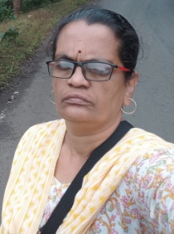
Name:-VandanaGovindKelkar.
Birth date:- 19/09/1968
Qulification:-M. A.(Mar. Hind.)M. Lib. M. Phil.
Designation:-Librarian
Professional Experience:-30 Years
Presented paper:- (2016-2017 to 2020-2021)
Sr. No | Academic Year | Name of the paper | ISBN/ ISSN
01 | 2018-2019 | कलाप्रेमी राजा-(Book Chapter) | लोकराजा राजर्षी(युगप्रवर्तक प्रकाशन लातूर) ISBN978-81-973477-1-1
02) |  | भाषेचा सामाजिक अभ्यास-(Jaysingpur college, Jaysangpur. Date:21-09-2019 | --- | National
03 |  | Internet and Tourism( Y. C. College, Halkarni) | ISBN-978-93-83797-5-19 | National
04 | 2020-2021 | Sustainable Development Goal:-Gender Equality | Interdisciplinary Research Journal (AIIRJ)  Peer Reviewed And Indexed Journal  ISSN 2349-638x  Impact Factor 7.149 | International
05) |  | Emojis:Popular Communication Tool( Y. C. College, Halkarni) | ISBN 978-93-83796-59 | National

1 | Link | Blog Linkedin YouTube
2 | Activity | IPR  Gender Equity  Plagiarism

